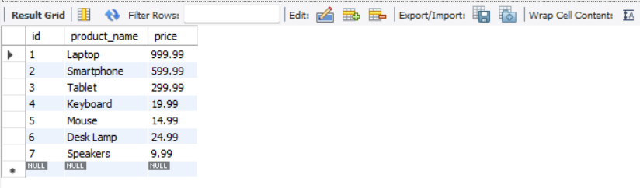

create database Prices_and_Product;

use Prices_and_Product;

create table products(

id int auto_increment primary key,

product_name varchar(100) not null,

price decimal(10, 2)

CHECK (price > 0)

);

describe products;

select *from products;

insert into products (product_name, price) values

('Laptop', 999.99),

('Smartphone', 599.99),

('Tablet', 299.99),

('Keyboard', 19.99),

('Mouse', 14.99),

('Desk Lamp', 24.99),

('Speakers', 9.99);

alter table products modify column product_name varchar(120) not null;

describe products;